# VISVESVARAYA TECHNOLOGICAL UNIVERSITY

#### Jnana Sangama, Belgaum-590018



A PROJECT REPORT **(18CSP83)** ON

“COFFEE SYSTEM USING HAND GESTURES”

**Submitted in Partial fulfillment of the Requirements for the Degree of Bachelor of Engineering in Computer Science & Engineering**

**By**

### BHOOMIKA P (1CR20CS041)

### CHARAN KN (1CR20CS044)

**MANJUNATH ASHOK NAYAK (1CR21CS409)**

**Under the Guidance of, Dr. Shreekanth HoD, Dept. of CSE**

**Prof. Hemangi**

**Assistant Professor, Dept. of CSE**

### DEPARTMENT OF COMPUTER SCIENCE AND ENGINEERING CMR INSTITUTE OF TECHNOLOGY

#132, AECS LAYOUT, IT PARK ROAD, KUNDALAHALLI, BANGALORE-560037

CMR INSTITUTE OF TECHNOLOGY

#132, AECS LAYOUT, IT PARK ROAD, KUNDALAHALLI,BANGALORE-560037

**DEPARTMENT OF COMPUTER SCIENCE AND ENGINEERING**



# CERTIFICATE

Certified that the project work entitled **“COFFEE SYSTEM USING HAND GESTURES”** carried out by **Ms**. **BHOOMIKA P (1CR20CS041)**, **Mr**. **CHARAN KN (1CR20CS044)**, **Mr. MANJUNATH ASHOK NAYAK (1CR21CS409)** bonafide students of CMR Institute of Technology, in partial fulfillment for the award of **Bachelor of Engineering** in Computer Science and Engineering of the Visveswaraiah Technological University, Belgaum during the year 2023-2024. It is certified that all corrections/suggestions indicated for Internal Assessment have been incorporated in the Report deposited in the departmental library.

The project report has been approved as it satisfies the academic requirements in respect of Project work prescribed for the said Degree.

.

|  |  |  |
| --- | --- | --- |
| **Prof. Hemangi**  **Assistant Professor**  **Dept. of CSE, CMRIT** | **Dr. Shreekanth M Prabhu Professor & Head**  **Dept. of CSE, CMRIT** | **Dr. Sanjay Jain Principal**  **CMRIT** |

**External Viva**

Name of the Examiners Signature with Date



# DECLARATION

We, the students of Computer Science and Engineering, CMR Institute of Technology, Bangalore declare that the work entitled "**COFFEE SYSTEM USING HAND GESTURES**" has been successfully completed under the guidance of Prof. Hemangi, Assistant Professor Dept, of CSE, Computer Science and Engineering Department, CMR Institute of technology, Bangalore. This dissertation work is submitted in partial fulfillment of the requirements for the award of Degree of Bachelor of Engineering in Computer Science and Engineering during the academic year 2023 - 2024. Further the matter embodied in the project report has not been submitted previously by anybody for the award of any degree or diploma to any university.

Place: BANGALORE

Date:

**Team members: Signature**

|  |  |
| --- | --- |
| **BHOOMIKA P(1C20CS041)** |  |
| **CHARAN KN(1CR20CS044)** |  |
| **MANJUNATH ASHOK NAYAK(1CR21CS409)** |  |

# ABSTRACT

With the assistance of the internet, teaching isn't restrained withinside the classroom for students. As we know, there already exist e-learning websites such as Coursera, Udemy, NPTEL etc which give numerous courses and assignments, helping students to gain the knowledge on the selected topics and fields.

It is provided through electronic devices such as computers, tablets and mobile phones that are connected to the internet. Students also get the chance to uplift their skills and knowledge apart from school education. E-learning platforms can also be used by teachers and working professionals apart from students, to gain the advanced skills and higher form of thinking. It provides innovative learning techniques.

The e-learning app has a mixture of content, media and technology to make learning more interactive and interesting among the students. Natural Language Provider helps the computer programs that translate the provided text from one language to another needed language, and sums up the large text very quickly.

# ACKNOWLEDGEMENT

I take this opportunity to express my sincere gratitude and respect to **CMR Institute of Technology, Bengaluru** for providing me a platform to pursue my studies and carry out my final year projectI have a great pleasure in expressing my deep sense of gratitude to **Dr. Sanjay Jain,** Principal, CMRIT, Bangalore, for his constant encouragement.I would like to thank **Dr. Shreekanth M Prabhu,** Professor and Head, Department of Computer Science and Engineering, CMRIT, Bangalore, who has been a constant support and encouragement throughout the course of this project.I consider it a privilege and honor to express my sincere gratitude to my guide

**Prof. Hemangi, Assistant Professor,** Department of Computer Science and Engineering, for the valuable guidance throughout the tenure of this review.I also extend my thanks to all the faculty of Computer Science and Engineering who directly or indirectly encouraged me. Finally, I would like to thank my parents and friends for all their moral support they have given me during the completion of this work.

|  |
| --- |
| **BHOOMIKA P(1C20CS041)** |
| **CHARAN KN(1CR20CS044)** |
| **MANJUNATH ASHOK NAYAK(1CR21CS409)** |

**TABLE OF CONTENTS**

|  |  |
| --- | --- |
|  | **Page No.** |
| **Certificate** | **ii** |
| **Declaration** | **iii** |
| **Abstract** | **iv** |
| **Acknowledgement** | **v** |
| **Table of contents** | **vi** |
| **List of Figures** | **viii** |
| **List of Tables** | **x** |
| **List of Abbreviations** | **xi** |
| **1. INTRODUCTION** | **1** |
| **1.1. Relevance of the Project** | **2** |
| **1.2. Problem Statement** | **3** |
| **1.3. Objective** | **3** |
| **1.4. Scope of the Project** | **3** |
| **1.5. Software Methodology** | **3** |
| **1.6. Schedule** | **4** |
| **1.7. Chapter Wise Summary** | **4** |
| 1. **LITERATURE SURVEY**    1. **Factors influencing learner attitudes towards e-learning and development of e-learning environment based on the integrated e- learning platform**    2. **A Markov chain collaborative filtering model for course entrollment recommendation**    3. **Collaborative filtering recommender system**    4. **Artificial intelligent based chatbot for placement activity at college using DialogFlow**    5. **Knowledge-based systems to enhance learning: A study on formal** | **5** |
| **5** |
| **7** |
| **10** |
| **11** |
| **14** |

|  |  |
| --- | --- |
| **languages and automata theory**  **2.6. Chapter Wise Summary** | **15** |
| 1. **PROPOSED ARCHITECTURE AND DESIGN**    1. **System Architecture**    2. **Use Case Flow Diagram**    3. **Data Flow Diagram**    4. **Chapter Wise Summary** | **16**  **16**  **17**  **19**  **19** |
| 1. **IMPLEMENTATION**    1. **Admin Module**    2. **Student Module**    3. **Chat Bot**    4. **Course Recommender**    5. **Chater Wise Summary** | **20**  **20**  **22**  **23**  **26**  **27** |
| 1. **RESULT AND DISCUSSION** 2. **CONCLUSION AND FUTURE SCOPE**    1. **Conclusion**    2. **Our Contribution**    3. **Future Scope REFERENCES** | **28**  **38**  **38**  **38**  **38**  **39** |

**LIST OF FIGURES**

|  |  |
| --- | --- |
|  | **Page No.** |
| **Fig 1.1 TUTORPAD interface** | **2** |
| **Fig 1.2 Schedule of the project** | **4** |
| **Fig 2.1 Architecture of the e-learning platform** | **6** |
| **Fig 2.2 Application environment of the integrated e-learning** | **7** |
| **Fig 2.3 Dialogflow based chatbot process flow** | **13** |
| **Fig 2.4 Flow of user and chatbot interaction(One Protocol)** | **13** |
| **Fig 2.5 System Knowledege Based Components** | **15** |
| **Fig 3.1 Proposed System Architecture** | **17** |
| **Fig 3.2 Use Case Diagram** | **18** |
| **Fig 3.3 Data Flow Diagram** | **19** |
| **Fig 4.1 Admin Module** | **20** |
| **Fig 4.2 Student Module** | **22** |
| **Fig 4.3 ChatBot** | **24** |
| **Fig 4.4 Conversation** | **24** |
| **Fig 4.5 Course Recommender** | **26** |
| **Fig 4.6 The collaborative filtering process** | **27** |
| **Fig 5.1 Home page** | **29** |
| **Fig 5.2 List course** | **29** |
| **Fig 5.3 Login/Registered user** | **30** |
| **Fig 5.4 Dashboard** | **30** |
| **Fig 5.5 Add course** | **31** |
| **Fig 5.6 Course list** | **31** |
| **Fig 5.7 Add new lesson** | **32** |
| **Fig 5.8 Add new quiz** | **32** |
| **Fig 5.9 Categories** | **33** |
| **Fig 5.10 Manage profile** | **33** |
| **Fig 5.11 Private message** | **34** |

|  |  |
| --- | --- |
| **Fig 5.12 Recommender page Fig 5.13 Course enrolled**  **Fig 5.14 Course content Fig 5.15 Review of the quiz Fig 5.16 chatbot**  **Fig 5.17 Display of message in chatbot** | **34**  **35**  **35**  **36**  **36**  **37** |

# LIST OF TABLES

|  |  |
| --- | --- |
|  | **Page No.** |
| **Table 2.1 Sample enrollment data of four student**  **Table 2.2 Overview of collaborative filtering techniques** | **9**  **9** |

**LIST OF ABBREVIATIONS**

|  |  |
| --- | --- |
| **AI**  **CF** | Artificial intelligent  Collaborative filtering |
| **ML** | Machine learning |
| **SQL**  **XML** | Structured query language  extensible markup language |

**CHAPTER 1**

# INTRODUCTION

The significance and contribution of e-learning systems, used as a supplement withinside the educational method, is unquestionable in everyday things, and it's miles bigger apparent in instances of internment eventualities, like one in all the things we tend to face currently as a result of the CORONAVIRUS health crisis (COVID-19 pandemic).

During this context, conveyance e-learning systems and promoting their use becomes one in all the basic challenges addressed via the suggests that of the many universities[7]. coming up with and developing systems that assist or promote learning has frequently been a multi-disciplinary concern.

The web, that is that the most vital and largest network, has clothed to be a major tool for the teaching-learning method. Systems that give to learners Associate in Nursing exercise and therefore the thanks to solve it step by step . Then, those systems produce comparable exercises, normally changing information, which can be solved through following the learnt steps[8].

The student, once visiting the TUTOR PAD, is supplied with the chat help, (“Greetings, however am i able to assist you”) for basic doubt clarification for the courses they need to require up to and concerning the web site. The chat help is enforced victimisation of the AI analysis methodology. It speedily answers all the queries raised by the scholars.

Artificial intelligence (AI) could be a wide-ranging branch of engineering science involved with building sensible machines capable of performing arts tasks that generally need human intelligence. At its core, AI is the branch of engineering science that aims to answer Turing's question within the affirmative. It's the endeavour to duplicate or simulate human intelligence in machines.

In the TUTORPAD all the access is taken by ADMIN. He administers all the scholars and therefore the courses, history of incoming, manage the profile, list of the quizzes results.

We have 3 completely different classes within the e-learning website- like beginners, intermediate and advanced. We tend to use course recommenders to grant suggestions of courses to the scholars when every course supported their levels in their chosen field.

The TUTORPAD saves all the info within the information victimisation MySQL. MYSQL is the most well liked Open supply SQL management system, developed, distributed, and supported by Oracle Corporation. A {relational information base|electronic database|on-line database|computer database|electronic information service} stores data in separate tables instead of putting all the info in one huge stowage.

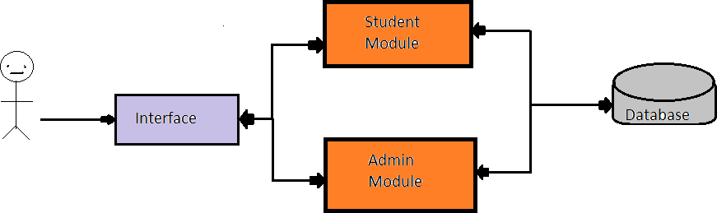

**Fig 1.1 TUTORPAD Interface**

## Relevance of the project

The importance of TUTORPAD in education is that it's quick and does not require much cost. The cost of papers, books, infrastructures, travel expenses, stationery etc is reduced to its lowest.

Helps students and teachers to develop their skills to advance level. The main motive of this project is to give education to people without any age restriction.

The e-learning system is used as an alternative in the learning process, does not create much impact in normal day to day life, but creates a huge impact in lockdown scenarios.

## Problem statement

While learning in an online system, it offers the unlimited freedom to choose your study fields around the students' private and professional commitments. Therefore the TUTORPAD is developed keeping in mind to provide the self study education to the students inspite of their age.

AI POWERED NATURAL LANGUAGE ADVISOR is the project which is developed to implement such an education system called TUTORPAD and make the students life easier.

## Objectives

Creativity is required with good human computer interaction knowledge. An intelligent tutoring system is proposed in this project to encourage students to learn through experiment, proposing tasks on their own initiative, which involves putting into use all the skills, abilities, tools and knowledge needed to successfully solve them.

## Scope of the project

Identify the scope of the project such that the objectives and goals of your project can be met.

Mention any elements that are essential for successful completion of your project. Identify constraints in your project.

## Software Methodology

TUTORPAD uses a constructivist approach to learning. This means that we believe that people reflect on their previous experiences to build new knowledge.

The “ AI POWERED NATURAL LANGUAGE ADVISOR” helps this theory to be implemented in real time so students can Learn -> Try -> Apply.

## Schedule

The project was carried out from October 2021 in two phases. In phase one the Planning, Research and Design was done and in phase two implementation was carried out.

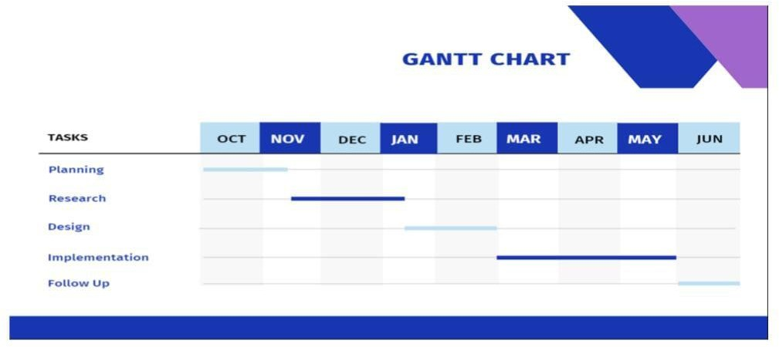

## Fig 1.2 Schedule of the project

* 1. **Chapter Wise Summary**

So in this chapter, we mainly learn about the problem statement that students can do their self-studies using the online learning platform. We have created a TUTORPAD platform where students can register themselves and learn the courses they want among the vast available courses and lessons. The process is mentioned in the problem statement and in the methodology section.

The web, that is that the most vital and largest network, has clothed to be a major tool for the teaching-learning method. Systems that give to learners Associate in Nursing exercise and therefore the thanks to solve it step by step . Then, those systems produce comparable exercises, normally changing information, which can be solved through following the learnt steps.

The e-learning system is used as an alternative in the learning process, does not create much impact in normal day to day life, but creates a huge impact in lockdown scenarios.

**CHAPTER 2**

# LITERATURE SURVEY

## Factors Influencing Learner Attitudes Toward E-learning and Development of E-learning Environment Based on the Integrated E-learning Platform

**Author :** Ding Aixia and Dan Wang

**Publisher :** Elsevier

#### Year of publication : 2011

**Objectives :** An E-learning platform is becoming a field of research that deserves the attention of the teaching and research community, so more and more universities have invested a huge amount of resources to implement their e-learning platform or environment.

However, the traditional E-learning system, which is used to deliver and manage contents and learning, can no longer provide the processes required to sustain the interest of a student as he learns.

As a result many e-learning facilities ended up as merely file servers. Recently, blogs and personal pages have recently emerged as popular uses of the Internet for people to learn, share and interact with people from all walks of life across the world. And with the popularity of E-learning increasing among academic and training institutions, learning and knowledge building have become a highly integrated and interactive global process[1].

For this reason, an integrated E-learning platform appears as a result of the efforts to make a step forward towards a more effective quality. E-learning presents an opportunity to enhance learning to create environments where students and teachers can share knowledge.

**Experimental Setup(if research):** Online E-learning is an effective alternative to traditional face-to-face education. Compared with school education, web-based education makes a great change in its space, time, method of teaching and learning. Many institutions implement an E-learning environment to meet students’ needs. Since E-learning is conducted using the Internet and World Wide Web, the learning environment becomes more complicated.

The integrated E-learning platform is considered to be a good way to support teaching and learning activities based on knowledge management.

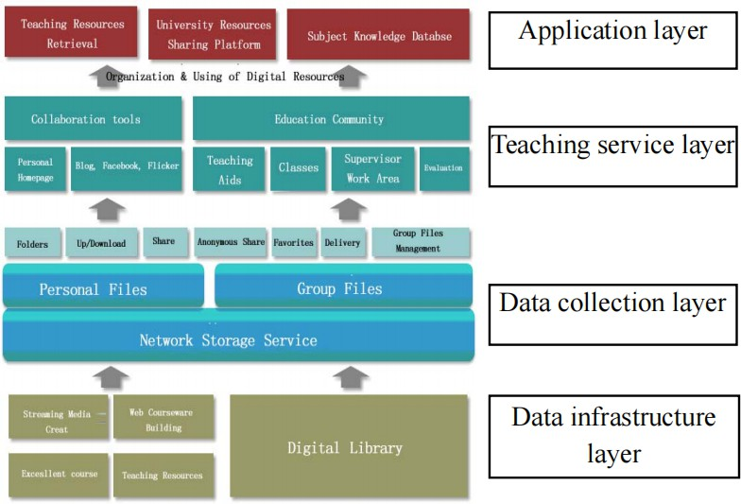

#### Fig 2.1 Architecture of the e-learning platform [1]

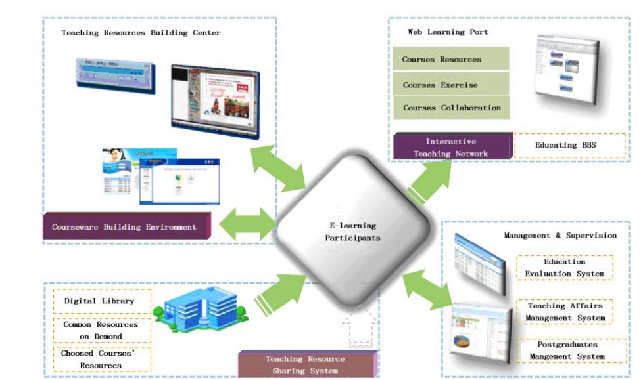

**Fig 2.2 Application environment of the integrated e-learning [1]**

**Major Result:** In this paper, we have presented an integrated E-learning platform interacting and participating in the educational process, which can be the answer to the many challenges faced by today’s E-learning administrators and implementers. The goal is to build a comprehensive teaching, research, service, innovation and network interaction platform through further integration of the school and outside of teaching, research, country, industry, policy, demand and other digital resources and learning courseware.

## A Markov Chain Collaborative Filtering Model for Course Enrollment Recommendations

**Author :** Elham S.Khorasani, Zhao Zhenge, John Champaign

**Publisher :** IEEE

#### Year of publication : 2016

**Objectives :** Collaborative-filtering is a recommendation approach that uses similarity between users and the benefit they have received from items in the past to make recommendations. People are most familiar with this style of recommendation from purchases on Amazon.com, an online retailer, which makes recommendations based on both a particular user’s purchase history and on the basis of other users’ common purchases.

Three main approaches to collaborative filtering are memory-based, model-based and hybrid methods [2]. Memory-based approaches use a user-item rating matrix to compute pairwise similarities between users or items and use the similarity values to predict ratings and make recommendations.

**Experimental Setup(if research):** To account for the order of courses in the collaborative filtering method, we model the sequence of courses that a student takes as a Markov process in which the courses a student will take in semester k + 1 depend only on the courses that he/she has taken in the previous k semesters.

A state in the basic Markov model is represented as a set of k courses taken in k consecutive semesters: s = {c1, c2, c3, ..., ck} The transition probability of going from state s1 = {c1, c2, c3, ..., ck} to state s2 = {c1, c2, c3, c4, ..., ck+1} can be estimated from the enrollment data using the Maximum Likelihood Estimation (MLE) as follows:

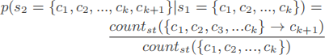

We calculate a recommendation score r(st, cj , j) for each course cj that a student st is likely to take in semester j, given his enrollments in k previous semesters, s1 = {cj−1, cj−2, ..., cj−k}, as follows:



#### Table 2.1 Sample Enrollment Data Of Four Students in Three Consecutive Semesters[2]

Step 1–Building the States Step 2–Finding Transitions

Step 3–computing Recommendation Scores

#### Table 2.2 Overview of collaborative filtering techniques[3]

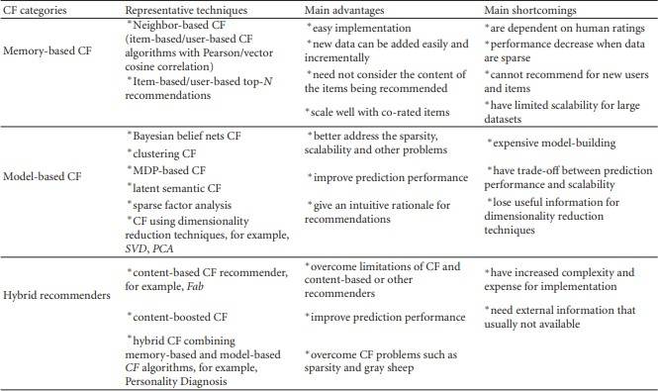

**Major Result:** In this work we examined, using historical data from students studying computer science, the effectiveness of a Markov based collaborative filtering course enrollment recommender. We argued that the order in which courses taken by students plays an important role in recommending new courses to students to take in their future semester. We showed that the precision and recall of the recommendations returned by the Markov model on this dataset outperforms those of item-based and matrix factorization-based recommender systems.

## Collaborative Filtering Recommender Systems

**Author :** J. Ben Schafer, Dan Frankowski, Jon Herlocker

**Publisher :** Springer

#### Year of publication : 2007

**Objectives :** Collaborative filtering (CF) is the process of filtering or evaluating items through the opinions of other people. CF technology brings together the opinions of large interconnected communities on the web, supporting filtering of substantial quantities of data.

We introduce the core concepts of collaborative filtering, its primary uses for users of the adaptive web, the theory and practice of CF algorithms, and design decisions regarding rating systems and acquisition of ratings.

We also discuss how to evaluate CF systems, and the evolution of rich interaction interfaces. We close the chapter with discussions of the challenges of privacy particular to a CF recommendation service and important open research questions in the field.

**Experimental Setup(if research):** The most well-known CF algorithms are nearest neighbour algorithms. We introduce the two different classes of nearest neighbour CF algorithms: user-based nearest neighbour and item-based nearest neighbour.



The GroupLens system for Usenet newsgroups, one of the first CF systems, defined userSim() in an equation using the Pearson correlation.

The Pearson correlation coefficient is calculated by comparing ratings for all items rated by both the target user and the neighbour (e.g. corated items). Equation 5 gives the formula for Pearson correlation between user u and neighbour n, where CRu,n. denotes the set of corated

items between u and n.

**Major Result:** Collaborative filtering is one of the core technologies that will power the adaptive web. Content-based personalization can be effective in limited circumstances, but for the most part, it will likely be decades or longer before our hardware and software technology can begin to automatically recognize the subtleties of information that are important to people – particularly aspects of aesthetic taste. Until then, in order to filter information based on such complex dimensions, we need to include people in the loop, who analyse the information and condense their opinions into data that can be easily processed by software – ratings. In this chapter, we have attempted to provide a snapshot of the current understanding of collaborative filtering systems and methods. By necessity, as masses of information become ubiquitously available, collaborative filtering will also become ubiquitous. In the process, we will continue to gain a deeper understanding of the dynamics of collaborative filtering.

## Artificial Intelligence based Chatbot for Placement Activity at College Using DialogFlow

**Author :** Sushil S. Ranavare, R. S. Kamath

**Publisher :** researchgate

#### Year of publication : 2020

**Objectives :** Chatbot is a simple computer program that attempts to simulate human conversation using Artificial Intelligence.It uses AI to simulate conversation with users through messaging chats or voice commands.These bots are used in many service areas as an information provider in online mode.

Natural Language Processing made the Chatbots more sophisticated by means of not only pre-programmed responses to user questions but also improving their responsiveness. AI based Chatbots have the prospective to transform certain practices in educational organisations.

We let the users test the systems and we evaluated the dialogue history in a particular session and all sessions by number of interactions. It was found that in topic specific knowledge Bot yields the best result for topic switching ratio and correction rate over BaseBot which confirms our hypothesis[5].

**Experimental Setup(if research):** This Chatbot is developed with the help of a Google owned DialogFlow interface which is commonly used to create Chatbots or NLP based Chatbots[5].

NLP enables machines to understand instructions provided in normal English in order to make computers easier to understand. It is “Build-once and deploys everywhere development suite” for developing interfaces for business websites, mobile applications, messaging platforms and so on.

It also offers a new analytical tool that can help in assessing usage patterns, latency issues and high intents of the agent. Because of GUI (Graphical User Interface), users who are not from a technical background can also easily build AI based Chatbot using DialogFlow.

When a user queries the agent, the Chatbot will try to match the defined phrases to match the user’s phrases. Based on these phrases the Chatbot will answer the user’s queries. If these phrases are described in various ways, then Chatbot can respond effectively [6].

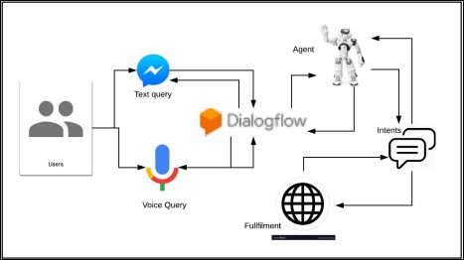

#### Figure 2.3 DialogFlow based Chatbot process flow[6]

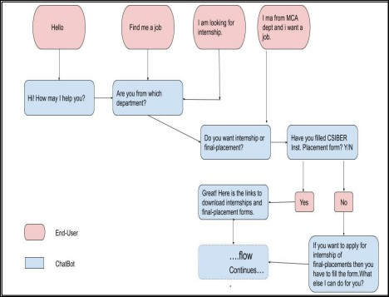

**Figure 2.4 Flow of User and Chatbot interaction(One Protocol)[6]**

**Major Result:** Design and development of AI based Chatbot for handling placement activities in professional college. This agent provides information related to placement activities to students. The NLP module of DialogFlow translates students’ queries into structured data in order to understand the institute's service.

## Knowledge-based systems to enhance learning: A case study on Formal Languages and Automata Theory

**Author =** J.J. Castro-Schez, J. Gallardo, R. Miguel, D. Vallejo

**Publisher =** Elsevier

#### Year of publication = 2017

**Objectives :** For many students, acquiring the conditional knowledge represents a great challenge. They know the concepts and are able to operate with them, but they do not know how to apply them at the right moment. In order to progress, the student must do a large amount of problem-solving exercises[9].

The InterBook approach uses two kinds of knowledge: knowledge about the domain being taught (represented in the form of a domain model) and knowledge about the students (represented in the form of individual student models).

The domain model serves as a basis for structuring the content of an adaptive ET. We distinguish two content parts in an adaptive ET: a glossary and a textbook[10].

**Experimental Setup(if research):** the process of designing and developing a specific e-learning system that provides a rich learning environment, in which students can learn in an active way proposing exercises and getting feedback, will be introduced(aims to be a representative example of how knowledge-based systems with a DSL-based communication interface could be useful in the field of online teaching by providing resources that help students build their own knowledge)

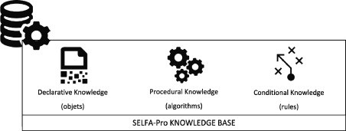

#### Fig 2.5 System Knowledge base components[9]

**Major Result:** In this paper, a knowledge-based approach was used in the design and implementation of an online tool for teaching and learning the subject of Formal Languages and Automata Theory, called SELFA-Pro.

In the development of this system, special emphasis was placed on establishing the contents of the subject, identifying the declarative, procedural, and conditional knowledge to be acquired, and modelling it in a way that allows the users to easily work with it.

As a future work, we plan to collect statistics which will then be used to determine the stage at which the student is in the learning process (i.e. the student’s learning profile). Moreover, we are going to develop and integrate a learning instructor module into SELFA-Pro.

This module will analyse the student’s learning profile, the current use of the tool and the context in which the tool is used with the aim to suggest possible learning tasks that improve his knowledge of the subject.

## Chapter Wise Summary

This chapter discusses the literature study for the proposed system, related paper which gives ideas of enhancements to the existing work. The related paper gives information about the existing systems, and its advantages and disadvantages.

**CHAPTER 3**

# PROPOSED ARCHITECTURE AND DESIGN

## System Architecture

The modules in this project are shown below and is depicted in Fig 3.1:

* + - **Recommender:**Recommender is built based on the concept of collaborative filtering technique. It contains a predefined dataset regarding upcoming modules and courses. This Recommendation system creates a prediction based on a user’s behaviours.
    - **Chat Bot:** Chat bot is built to provide lively interaction to users with the help of automation. Chat bot is built based on the concept of tokenization technique.Tokenization is a process of separating a piece of text into smaller units called tokens. We create a pre-defined intents with key and value. When an intent is matched at runtime, this system provides the extracted values to the end-user.
    - **Message:** Message is a feature which enables communication between learner and course admin for instant doubt clarification. Conversation between learner and course instructor is stored in a database for further reference.
    - **User Interface:** User interface provides separate visual graphics for student registration and login. The interface is built with the help of modern technologies for smooth interactions. After registration students can enrol to the courses.

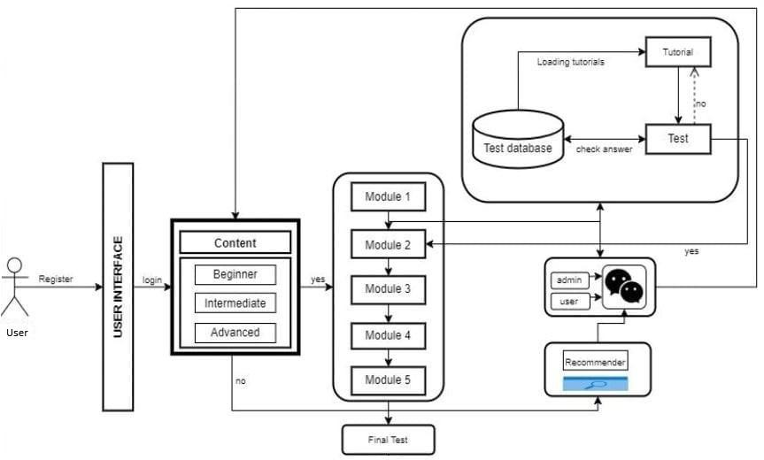

**Figure 3.1 Proposed System Architecture**

## Use Case Diagram

We have two sections: admin and student.

* + - Admin first login to the page he can add course,view the student enrolment history, manage student, profile sitting, registration, and also can reply to student messages or any query regarding the topics
    - Students first need to register and create their account and then login to their account for any help they can use the chatbot for instant reply regarding the course or other requirement , by searching or the list of courses available students can enrol to the course for any query they can directly message to the admin. We also have course recommenders for further courses if they require any guidelines, and also given the option for profile sitting.

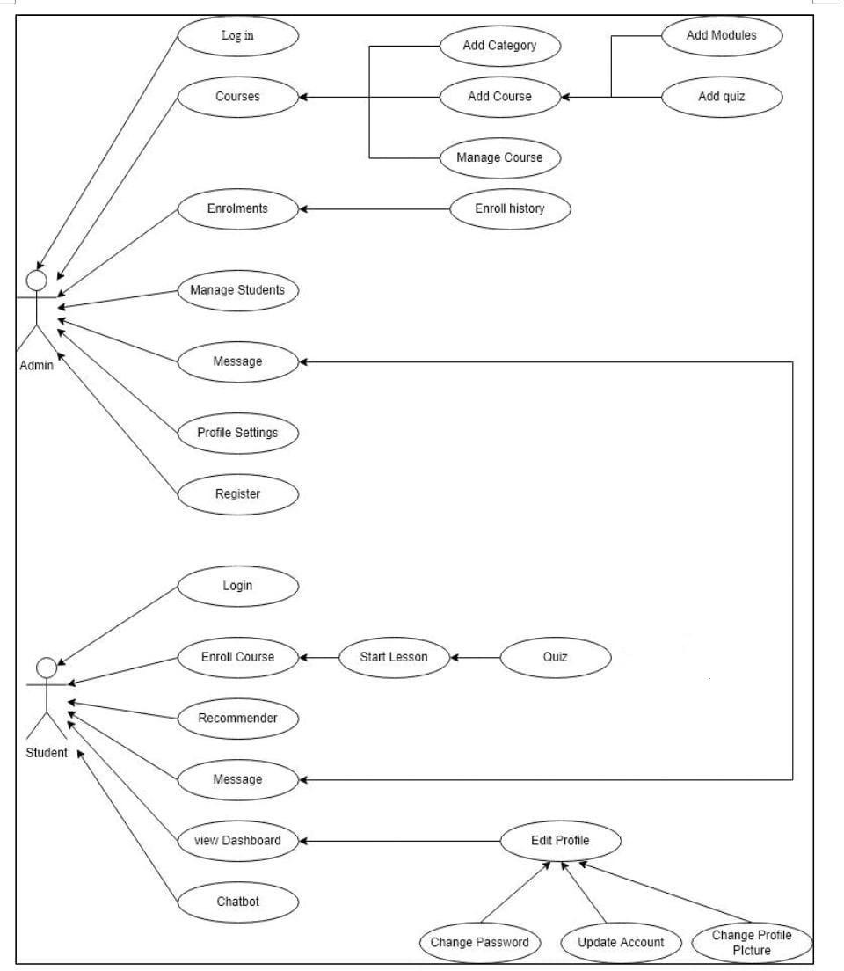

**Figure 3.2 Use Case Diagram**

## Data Flow Diagram

We have taken the Coursera.csv dataset and import it in collaborative filtering algorithm and implemented course recommender in our TUTORPAD website

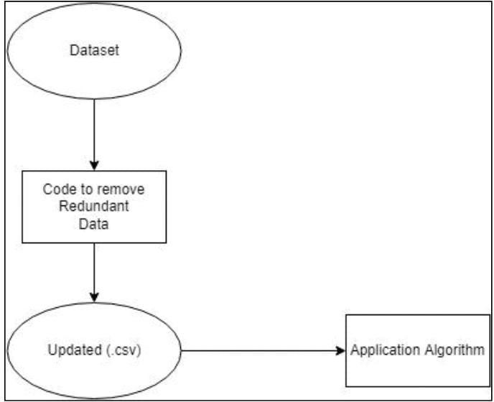

**Figure 3.3 Data Flow Diagram**

## Chapter Wise Summary

This chapter mainly concentrates on System Architecture design, use case diagram of the platform and also the dataset used in data flow diagram.

**CHAPTER 4**

# IMPLEMENTATION

The various aspects of the system are explained below the system was implemented in a PHP framework and the AI powered chatbot and course recommender integrated with the system is implemented in Python

## ADMIN module

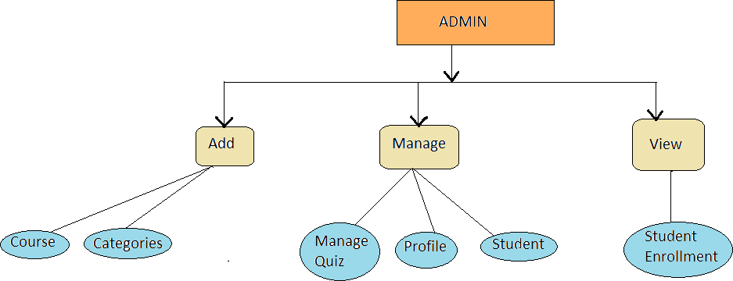

**Fig 4.1 Admin Module**

### ADD

* + - * Add Categories : The admin of the TUTORPAD can create the different categories such as Beginner, Intermediate and Advanced.
        + While creating the new category, category code is auto

generated. The admin needs to provide the category title, specify its parent or leave it as None, and specify the category thumbnail and icon picker. The click of submit will create the Submit.

* + - * Add Course: The admin of the TUTORPAD can add the different courses in the chosen category.
        + Admin needs to give the course title, short description, the

requirements for the course, the outcome of the courses. Admin can make the course free or fix the course price and discount.

He needs to specify the overview provider and overview URL along with a thumbnail.

### MANAGE

* + - * Manage Quiz: The admin of the TUTORPAD can add quiz at any level of the course.
        + The path for adding a quiz is : Courses -> Manage Courses ->

Add Quiz.

The admin has to provide the title of the quiz, include the section ( will be selected by default) and add instructions for the quiz: such as the passing marks, level of the quiz, topics covered, outcomes of the quiz. After clicking the submit,the quiz will be added.

* + - * + The admin has to click on the quiz to add the questions. He has

to provide the question title, mention the number of options, give the choices, mark the correct answer among the options given. Clicking on the submit will create the question in the quiz.

* + - * Manage Profile: The admin can manage his profile. The option of editing the First name, Last name, Email ID is given. He can link his facebook, Twitter and LinkedIn. He can provide his short description. The admin can update his password in the section at any given point of time.
      * Manage Student: The admin as the authority to manage the student profile. He can Edit the student profile, delete the student. He can view the number of courses each student has taken up.

### VIEW

* + - * Student Enrollment: The admin has the authority to check the enrollment history of each student. He can view the date of the course enrollment, and the number of courses each student has enrolled.

## STUDENT module

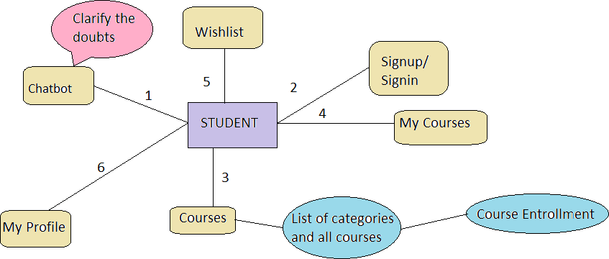

#### Fig 4.2 Student Module

* + 1. ChatBot: This section helps the student to ask questions. This clarifies the doubts of the student using AI technique. This will be discussed in further sections of paper in detail.
    2. SignUp/ Login: The student has to sign up for the first time and later on can log in into the website. The homepage of the TUTORPAD will be opened each time when students visit the page.
    3. Courses: In this section students can view the courses based on the categories the lessons are divided into and all the lessons under All courses option.
       - The modules will be displayed after hovering over the specific categories.
       - Through this section, students can enroll into their desired courses.
    4. My Courses: This section of the webpage gives the list of all the courses that the student has enrolled into based on the recently enrolled courses.
    5. Wishlist: This section of the page gives the list of all the courses that the student has put into the wishlist category.
    6. My Profile: Here the student can get all the information about his courses and his profile.
       - Students can update his basic details such as name, link his Facebook, Twitter and LinkedIn accounts, Email Id.
       - Students can change his profile photo.
       - Students can view his enrolled courses, wishlisted courses, messages and his profile.
       - Students can also view his purchase history.
       - Students can view the messages he has directly sent to the admin and their replies.
       - Students can also update his existing password.
       - Students can logout through the My Profile icon.

## Chatbot

The CHATBOT feature is enabled on the students main page in the bottom-right corner. The student greetings will always be visible to the students. On clicking on the greetings, a chat dialog box will appear. Students can ask questions, clarify their doubts. Based on the keywords present in the question, answers will be provided to the students.

We have integrated the Dialog Flow module in the chatbot. Dialog Flow is a platform that understands NLP and engages with users through different interfaces. The module Drupal Chatbot helps in building a chatbot using Dialog Flow as the NLP agent.

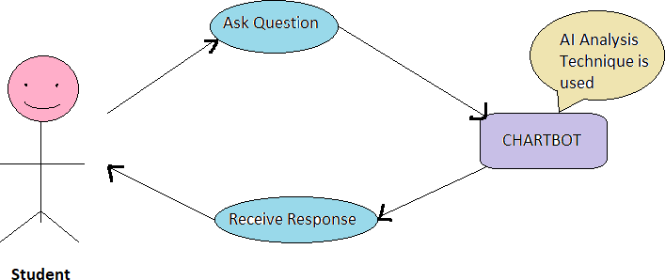

#### Fig 4.3 ChatBot

This feature helps in giving the answer or the related information to the students rapidly. Even if the AI does not clarify their doubts, students can personally drop a text or questions to the Admin directly. Dialogflow is a natural language understanding platform that makes it easy to design and integrate a conversational user interface into your mobile app, web application, device, bot, interactive voice response system, and so on. Using Dialogflow, you can provide new and engaging ways for users to interact with your product. Dialogflow can analyse multiple types of input from your customers, including text or audio inputs (like from a phone or voice recording). It can also respond to your customers in a couple of ways, either through text or with synthetic speech.

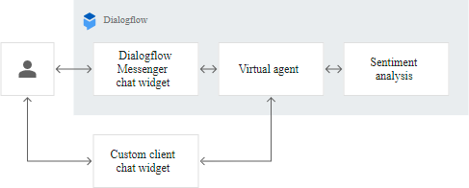

#### Fig 4.4 Conversation

Natural Language Processing is a computer science technology powered by Artificial Intelligence which enables the interaction between computer and human in natural language. It can be used in the development of chatbots, IVRs, Robots and many more to process user's input in the form of natural language.

The Dialogflow which is implemented in our project is based on AI analysis. When the student is logged in into the TUTORPAD, he is greeted with the welcome message - “Hello, how can I help you?”.

On clicking on the message, he is directed to the AI powered chatbot, in whose environment the student can ask any amount of questions and of any length. The NLP integrated helps the interaction between the student and the computer AI analysis in natural language. The response to the student will be given immediately in no amount of time.

All the questions and answers will be stored in an AI powered Dialogflow database. Admin has the access to add any amount of pre- decided questions and their answers in the database. This module is plugged into the TUTORPAD which helps the students to get their answers from the database.

If the questions asked by the student are present in the database, the answer will be provided to the student as it is. If the question asked by a student is not in the already present set of questions in the database, the keywords will be compared to the set of questions in the database and its related information will be provided to the student. If the student doesn't get satisfied by the provided answers, he can ask the questions with different keywords or message the Admin directly through the message icon.

## Course Recommender

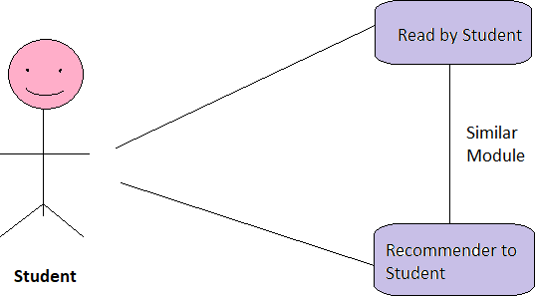

#### Fig 4.5 Course Recommender

Course Recommender is the feature which is integrated in TUTORPAD. This feature helps the students to get the suggestions for the most suitable course according to their previous module’s performance. The students can follow the Course Recommender and take up the suggested course or explore the available courses and choose his next desired course to take up.

For instance, when the student completes his nth course in the Beginners module, based on the marks scored in the quiz, either he will be suggested to take up the next course in Intermediate module or continue the next course in Beginners module.

Collaborative Filtering is the most common technique used when it comes to building intelligent recommender systems that can learn to give better recommendations as more information about users is collected

The goal of a collaborative filtering algorithm is to suggest new items or to predict the utility of a certain item for a particular user based on the user's previous likings and the opinions of other like-minded users. In a typical CF scenario, there is

a list of m users  and a list of n items  . Each user ui has a list of items Iui, which the user has expressed his/her opinions

about. Opinions can be explicitly given by the user as a rating score, generally within a certain numerical scale, or can be implicitly derived from purchase records, by analysing timing logs, by mining web hyperlinks and so on. Note that  and it

is possible for Iui to be a null-set. There exists a distinguished user  called the active user for whom the task of a collaborative filtering algorithm is to find an item likeliness that can be of two forms.

* **Prediction** is a numerical value, Pa,j, expressing the predicted likeliness of

item  for the active user ua. This predicted value is within the same scale (e.g., from 1 to 5) as the opinion values provided by ua.

* **Recommendation** is a list of N items,  , that the active user will like the most. Note that the recommended list must be on items not already

purchased by the active user, i.e.,  . This interface of CF algorithms is also known as Top-N recommendation.

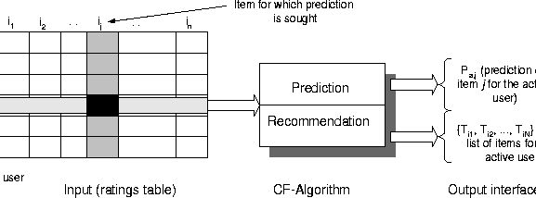

**Fig 4.6 The Collaborative Filtering Process**

## Chapter Wise Summary

The chapter describes the implementation process of the proposed system. It describes which platform, language, algorithms and processing techniques used for executing the project.

**CHAPTER 5**

# RESULTS AND DISCUSSION

Discussion methods are a variety of forums for open-ended, collaborative exchange of ideas among a teacher and students or among students for the purpose of furthering students' thinking, learning, problem solving, understanding, or literary appreciation. Students present multiple points of view, respond to the ideas of others, and reflect on their own ideas in an effort to build their knowledge, understanding, or interpretation of the matter at hand.

TUTORPAD is an online integrated software used for creating, delivering, tracking, and reporting educational courses and outcomes. It can be used to support traditional learning as well as blended/hybrid and distance learning environments. Schools use learning software to plan, implement, facilitate, assess, and monitor student learning. All of these activities are conducted behind a virtual wall that provides a measure of authentication, security, and privacy.

The student, once visiting the TUTOR PAD, is supplied with the chat help, (“Greetings, however am i able to assist you”) for basic doubt clarification for the courses they need to require up to and concerning the web site. The chat help is enforced victimisation of the AI analysis methodology. It speedily answers all the queries raised by the scholars.

The importance of TUTORPAD in education is that it's quick and does not require much cost. The cost of papers, books, infrastructures, travel expenses, stationery etc is reduced to its lowest. Helps students and teachers to develop their skills to advance level. The main motive of this project is to give education to people without any age restriction. The TUTORPAD system is used as an alternative in the learning process, does not create much impact in normal day to day life, but creates a huge impact in lockdown scenarios. AI POWERED NATURAL LANGUAGE ADVISOR is the project which is developed to implement such an education system called TUTORPAD and make the students life easier.

Below there are some screenshot mention about our project

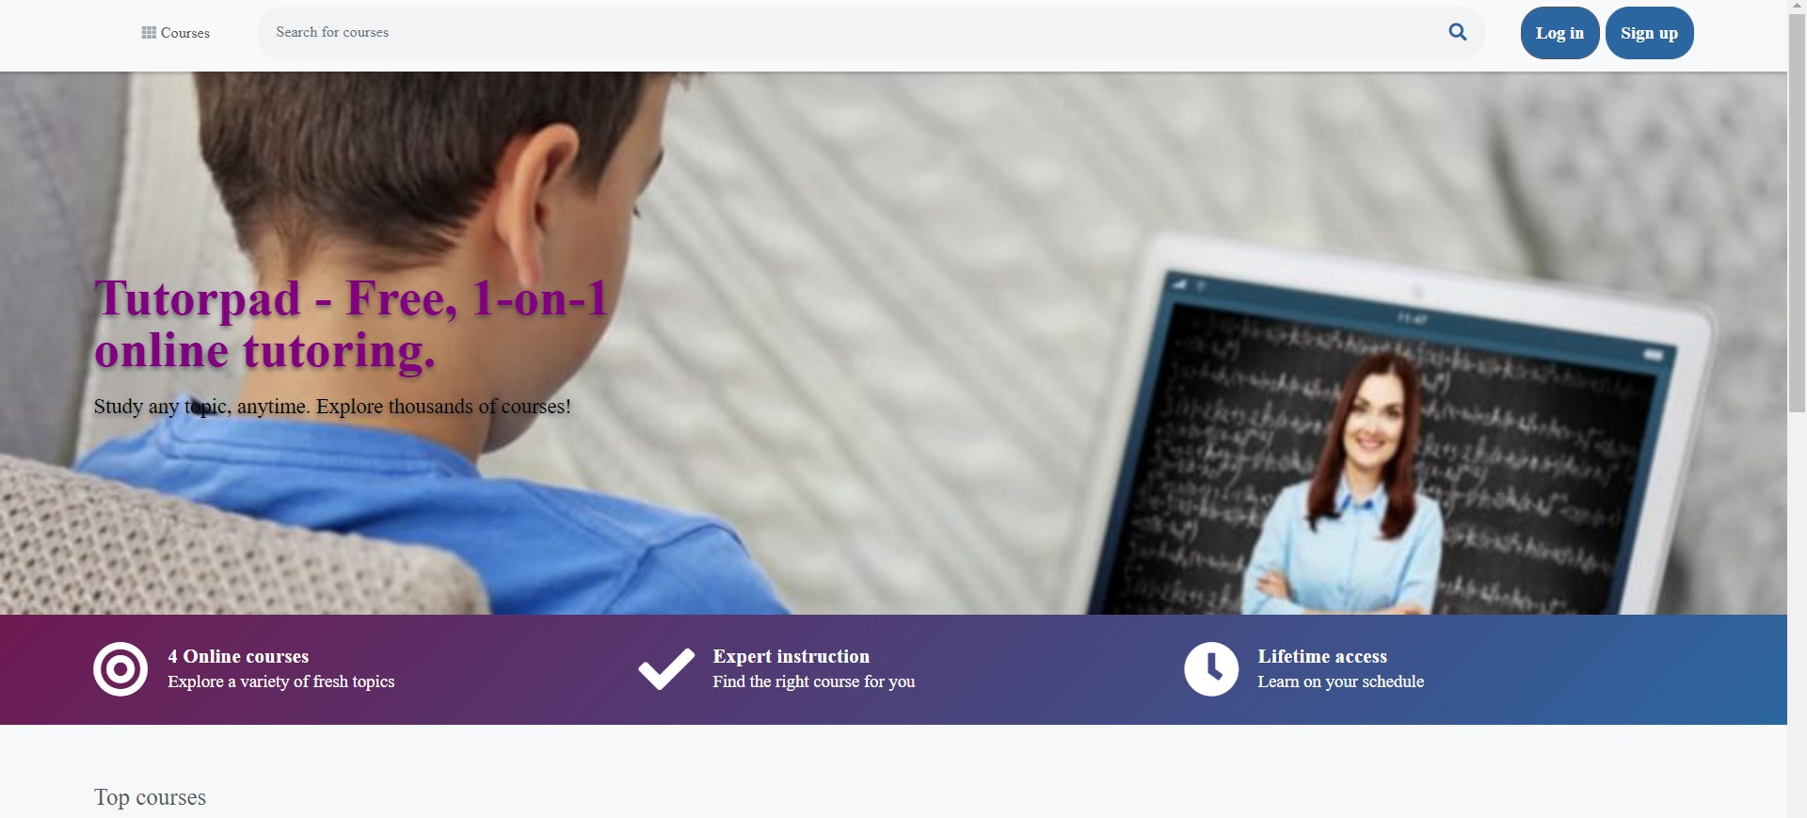

#### Fig 5.1 Home page

The Home Page of the Website where the student or Admin can easily Login/Sign Up.

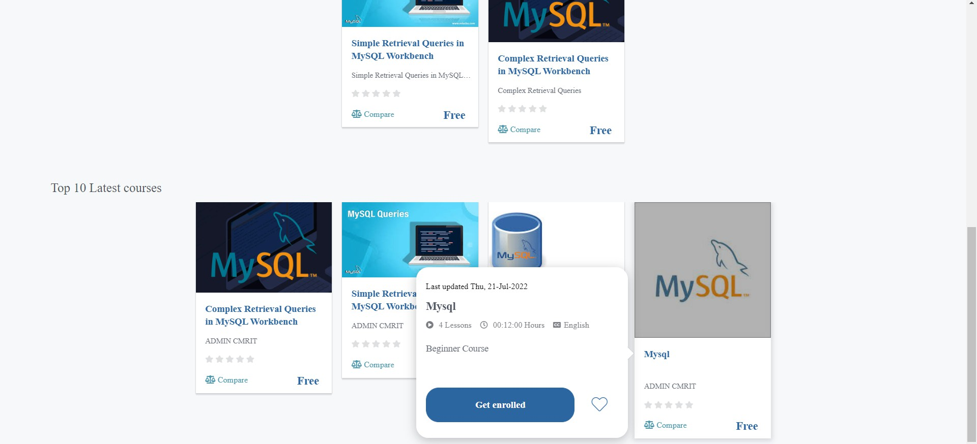

#### Fig 5.2 List of course

The Home page contains the Courses divided according to Top 10 latest Courses, where students can get enrolled.

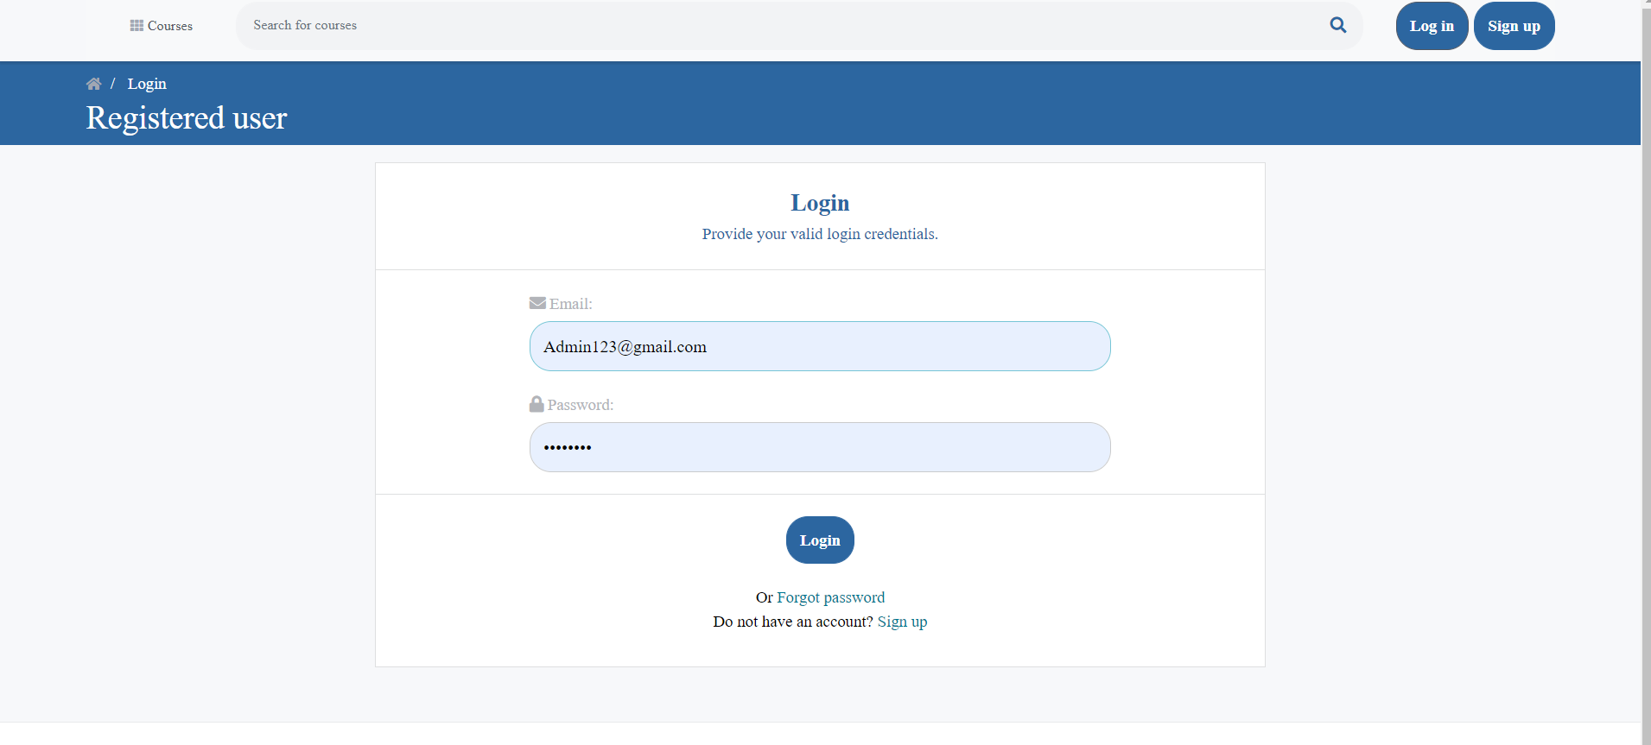

#### Fig 5.3 Login/Registered User

The Login page where the user has to specify their Email address and Password.

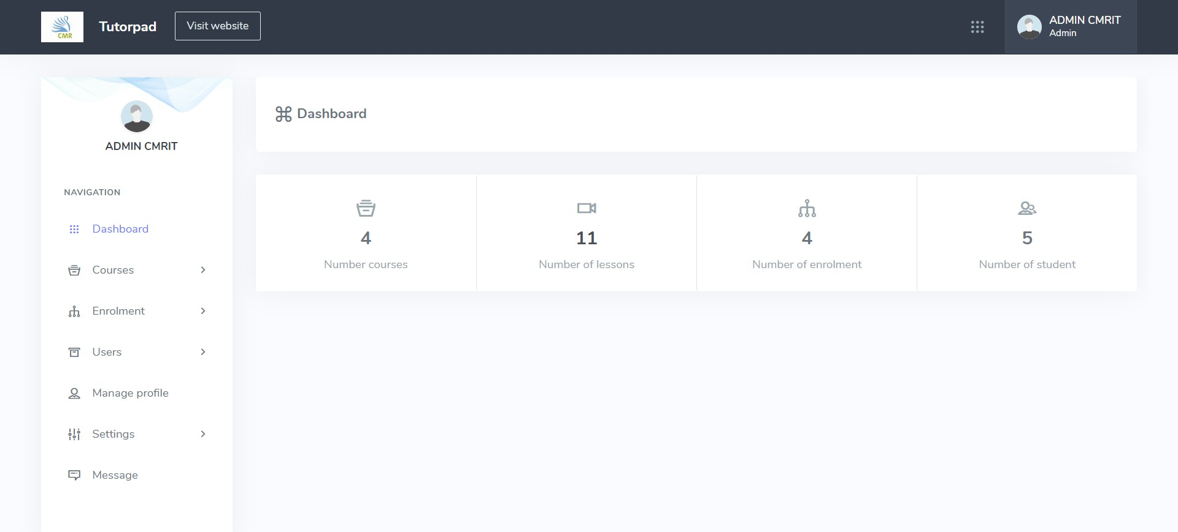

#### Fig 5.4 Dashboard

Admin Module - Dashboard which contains all the Number of Courses,Number of Lessons, Number of Enrollments and Number of Students.

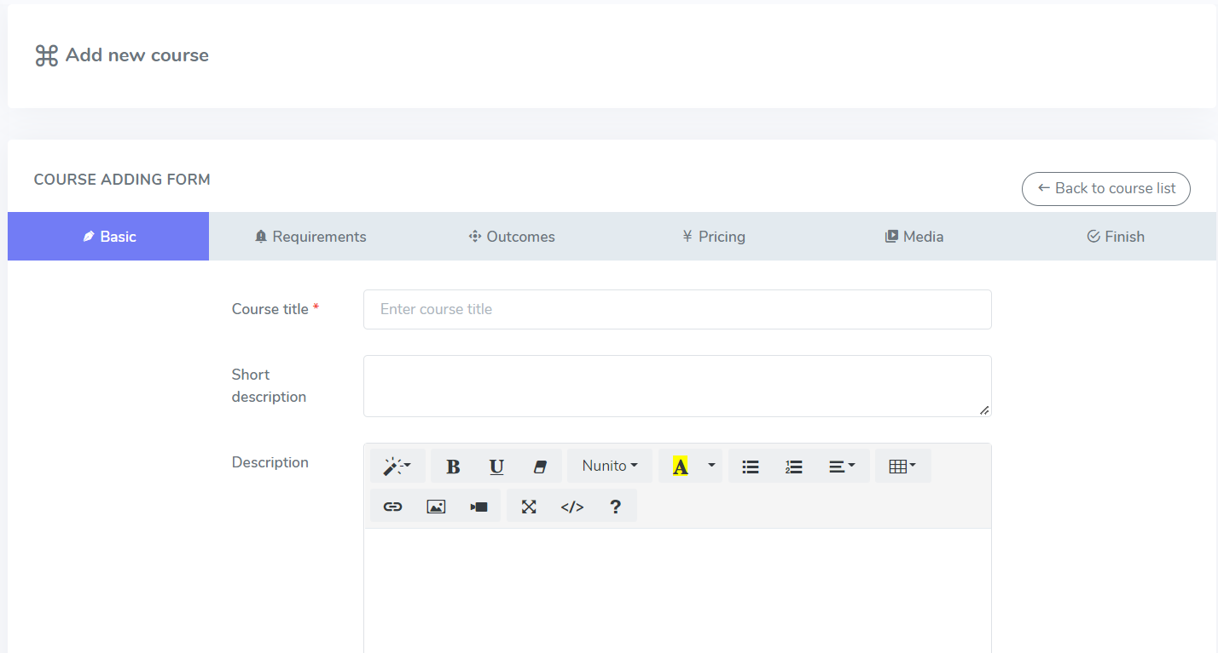

#### Fig 5.5 Add course

Add Course: The admin of the TUTORPAD can add the different courses in the chosen category.

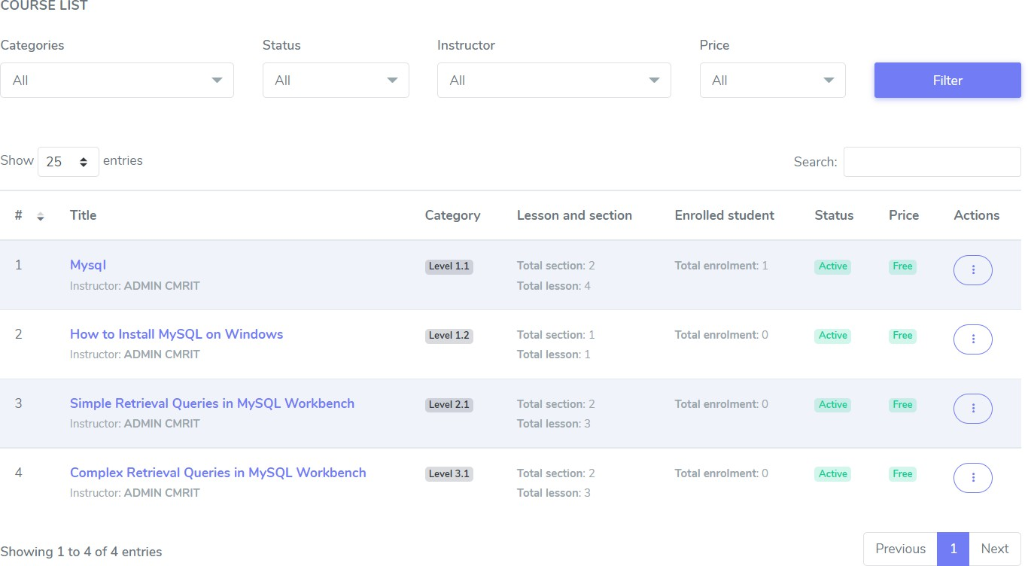

#### Fig 5.6 Course List

Course list added by the admin of the Tutorpad where the admin can Edit, Delete, Update the Course.

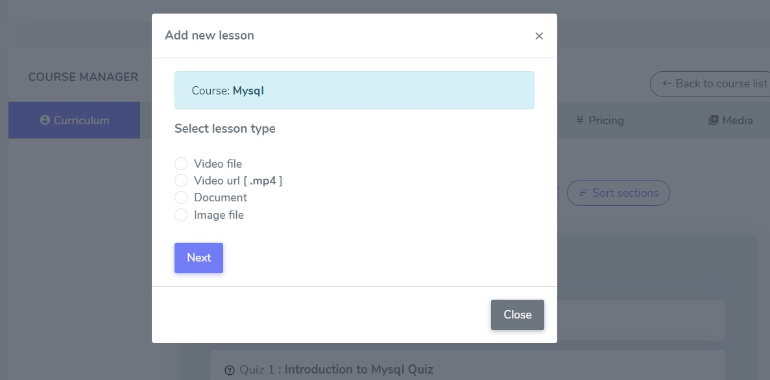

#### Fig 5.7 Add new lesson

Add new Lesson- Admin of TUTORPAD can add lessons according to his convenience either it can be a Document,Video File,Video Url,Image File.

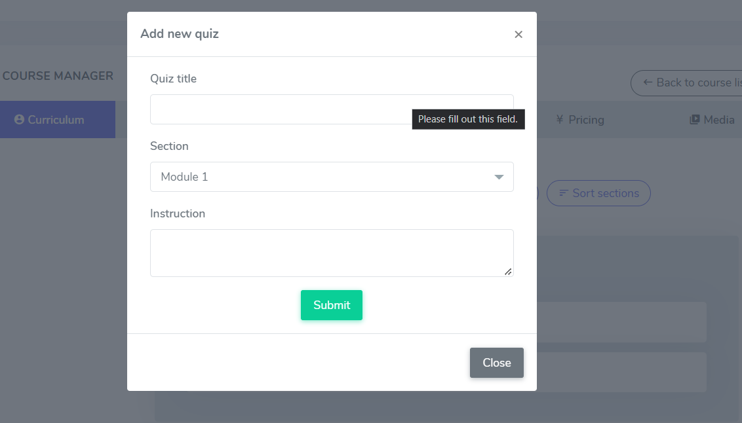

#### Fig 5.8 Add new quiz

Add new Quiz - The admin of TUTORPAD can add a quiz by giving the title for the quiz and instructions for the quiz.

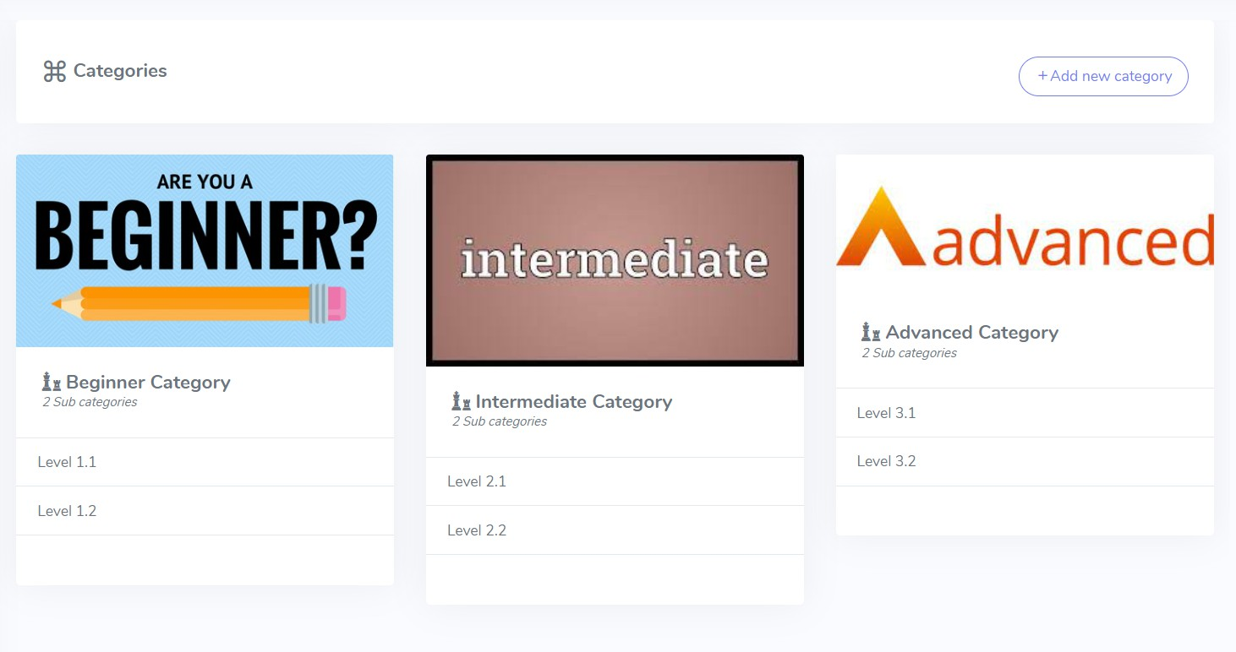

#### Fig 5.9 categories

Add new Category - Different Categories can be added by admin, for example: Beginner, Intermediate, Advanced.

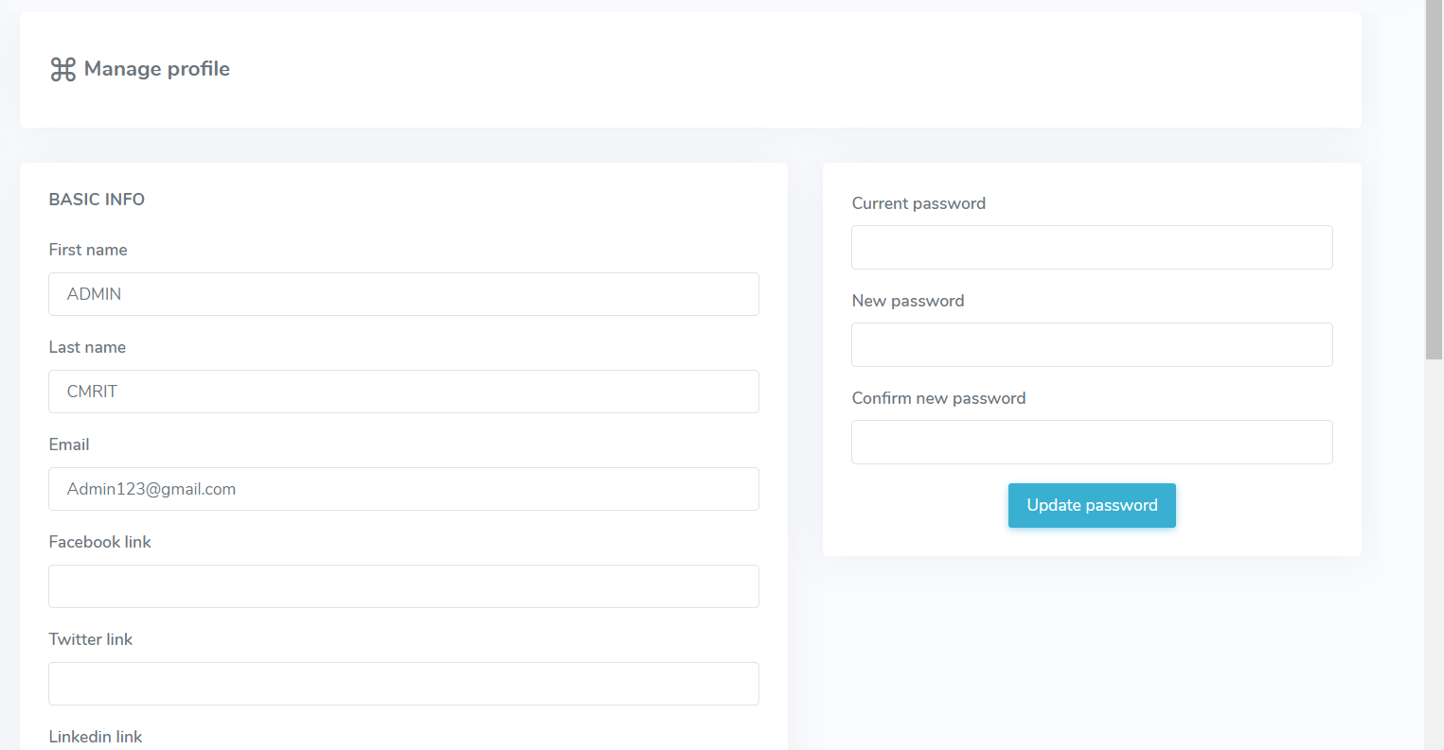

#### Fig 5.10 Manage profile

Manage Profile: The admin can manage his profile. The option of editing the First name, Last name, Email ID is given. He can link his facebook, Twitter and LinkedIn. He can provide his short description. The admin can update his password in the section at any given point of time.

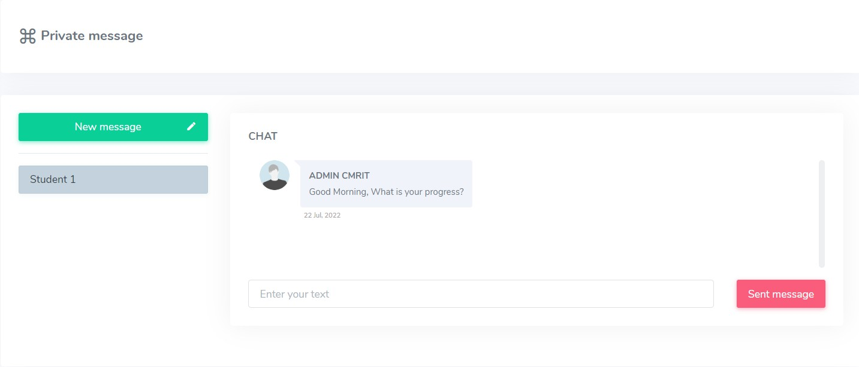

#### Fig 5.11 Private message

Message: Message is a feature which enables communication between learner and course admin for instant doubt clarification. Conversation between learner and course instructor is stored in a database for further reference.

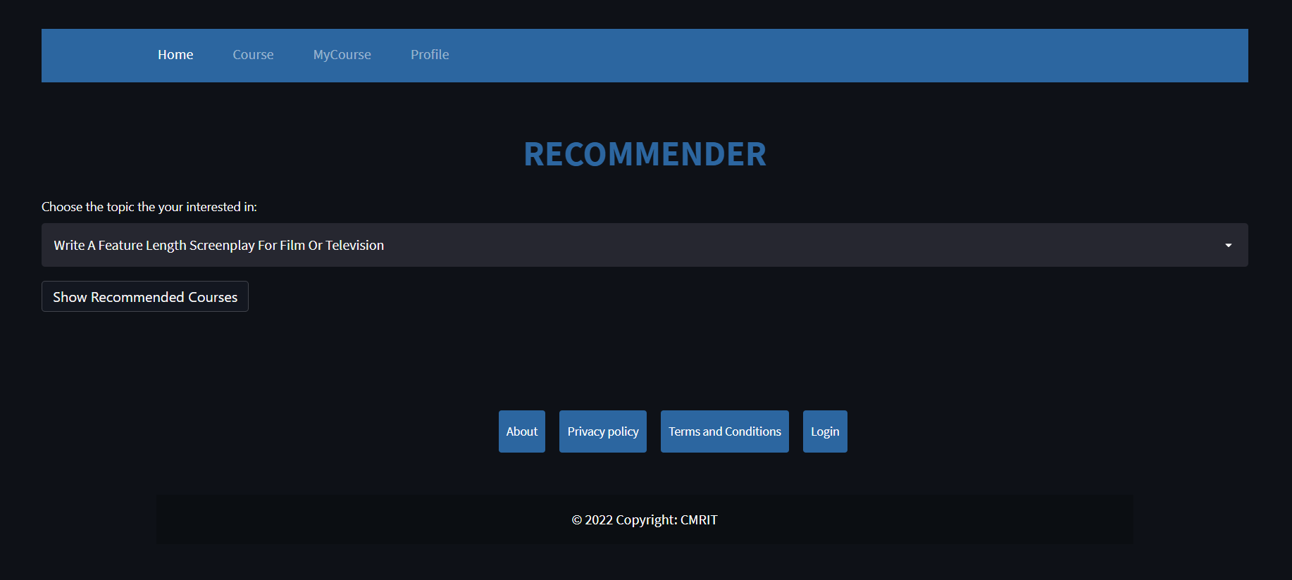

#### Fig 5.12 Recommender page

Recommender is built based on the concept of collaborative filtering technique. It contains a predefined dataset regarding upcoming modules and courses. This Recommendation system creates a prediction based on a user’s behaviours. Recommender recommends the courses on the topic the user is interested to learn.

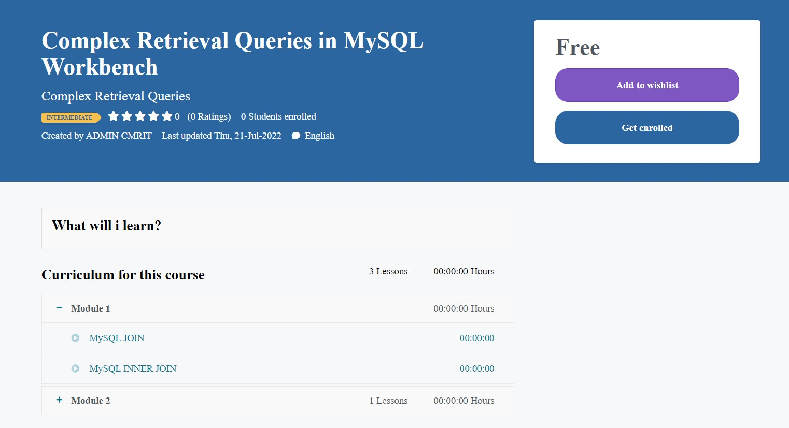

**Fig 5.13 Course enrolled**

Course description page where students can add the course to the wishlist or get enrolled.



#### Fig 5.14 Course content

Course Contents added by the admin and displayed to the user.

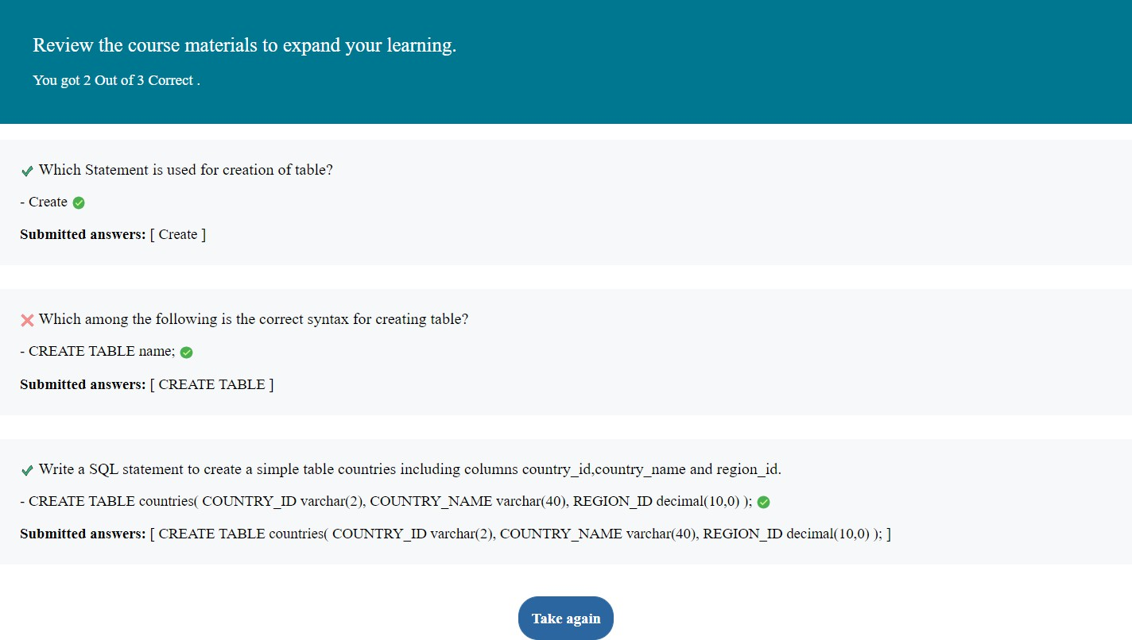

#### Fig 5.15 Review of the quiz

Result of the quiz where he can review his marks and check the correct answer for each question.

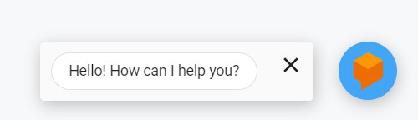

#### Fig 5.16 Chatbot

The CHATBOT feature is enabled on the students main page in the bottom-right corner. The student greetings will always be visible to the students.

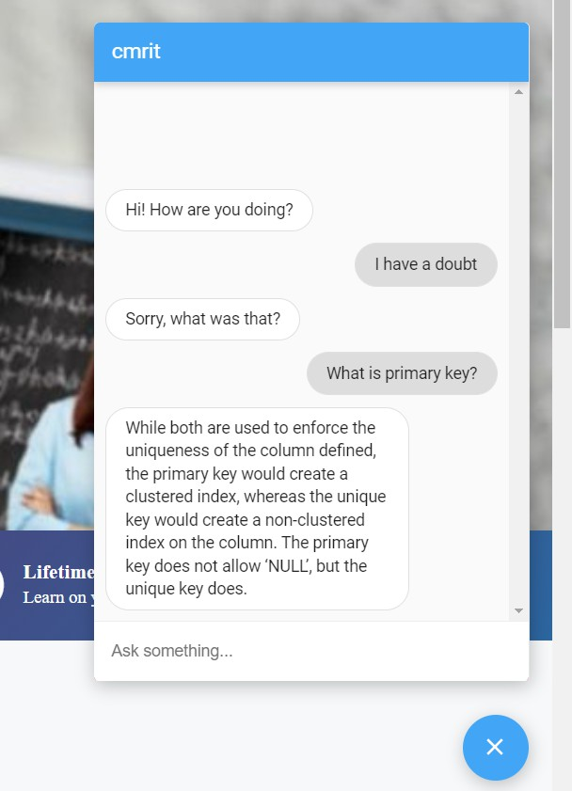

#### Fig 5.17 Display of Messages in Chatbot

This section helps the student to ask questions. This clarifies the doubts of the student using AI technique.On clicking on the message, he is directed to the AI powered chatbot, in whose environment the student can ask any amount of questions and of any length.

**CHAPTER 6**

# CONCLUSION AND FUTURE SCOPE

## Conclusion

The project TUTORPAD is developed mainly based on the feedback given by students and their needs for the courses. We have included different methods of teaching processes for different students such as video lessons, pdf lessons, image lessons. The students' performance indicates that after using the TUTORPAD, the students will learn different approaches for solving the problems and have a much better performance and knowledge than before. The website is not only useful for school and college going students but also for teachers and working professionals.

## Our Contribution

We have developed the web application AI-POWERED self learning tool for the teaching-learning process. We try analysing the Student behaviour and their speed of learning through the project.Learning is not a change in technology, It is the process for redefining how to build the knowledge, skills, and also values to upcoming generations students.We have given an option of chatbot so that before enrolling any course student can ask any question and get the response(we use AI Analysis for implementing the chartbot), and also after completing the course for each student there is a course recommender option it helps students to go for further courses. The major challenge of this project was to implement the AI and NLP Advisor powdered Chatbot and to import the course recommender module.

## Future scope

In future we would like to add a few more things to a TUTORPAD such as face-to-face interaction with teacher and student, live section and also paid courses for advanced level courses. And to make our website more easy and very flexible to use for users. and also giving and access to admin add a new instructor to teacher and add there course, Our long term goal is to make our website truly finish and advertise it to the user.

# REFERENCES

1. Ding Aixia and Dan Wang, “Factors Influencing Learner Attitudes Toward E-learning and Development of E-learning Environment Based on the Integrated E-learning Platform” Aug 2011, <http://www.ijeeee.org/Papers/043-Z0031.pdf>
2. Elham S.Khorasani, John Champaign Department of Computer Science University of Illinois at Springfield ,IL, USA, “A Markov Chain Collaborative Filtering Model for Course Enrollment Recommendations”, 2016 <http://hdc.cs.arizona.edu/people/zhenge/makrovchain.pdf>
3. X. Su and Taghi M. Khoshgoftaar, “A survey of collaborative filtering techniques,” Adv. in Artif. Intell., vol. 2009, pp. 4:2–4:2, Jan. 2009. Available: <http://dx.doi.org/10.1155/2009/421425>
4. J. Ben Schafer, Dan Frankowski, Jon Herlocker, and Shilad Sen, Oregon State University

Corvallis,Collaborative Filtering Recommender Systems” pp. 291 – 324,Jan 2007, [https://www.researchgate.net/publication/200121027_Collaborative_Filtering_Recom](https://www.researchgate.net/publication/200121027_Collaborative_Filtering_Recommender_Systems) [mender_Systems](https://www.researchgate.net/publication/200121027_Collaborative_Filtering_Recommender_Systems)

1. Supratip Ghose, Jagat Joyti Barua, Dept. of Computer Science and Engineering, University of Information Technology and Sciences Baridhara, Dhaka, Bangladesh, “Toward the implementation of a Topic specific Dialogue based Natural Language Chatbot as an Undergraduate Advisor” · May 2013 [research paper link](https://www.researchgate.net/profile/Supratip-Ghose/publication/236838062_Toward_the_implementation_of_a_Topic_specific_Dialogue_Based_Natural_Language_Chatbot_as_an_Undergraduate_Advisor/links/5cd1ce03458515712e98a90b/Toward-the-implementation-of-a-Topic-specific-Dialogue-Based-Natural-Language-Chatbot-as-an-Undergraduate-Advisor.pdf) .
2. Sushil S. Ranavare, R. S. Kamath, Department of Computer Studies ChhatrapatiShahu Institute of Business Education and Research Kolhapur, India, “Artificial Intelligence based Chatbot for Placement Activity at College Using DialogFlow**”,** 2020

[https://www.semanticscholar.org/paper/Artificial-Intelligence-based-Chatbot-for-Plac](https://www.semanticscholar.org/paper/Artificial-Intelligence-based-Chatbot-for-Placement-Ranavare-Kamath/0b541d3a11bb90b8b9715ac137102f629b7e41aa) [ement-Ranavare-Kamath/0b541d3a11bb90b8b9715ac137102f629b7e41aa](https://www.semanticscholar.org/paper/Artificial-Intelligence-based-Chatbot-for-Placement-Ranavare-Kamath/0b541d3a11bb90b8b9715ac137102f629b7e41aa)

1. Erik W. Black, Dennis Beck, Kara Dawson, Susan Jinks, “The other side of the LMS: Considering implementation and use in the adoption of an LMS in online and blended learning environments” March 2007, <https://link.springer.com/article/10.1007/s11528-007-0024-x>
2. Tanmay Kulshrestha, A Ravi Kant , Government Engineering College, Thrissur Kerala, India, “Benefits of Learning Management System (LMS) in Indian Education

”2013,[https://citeseerx.ist.psu.edu/viewdoc/download?doi=10.1.1.403.7793&rep=rep](https://citeseerx.ist.psu.edu/viewdoc/download?doi=10.1.1.403.7793&rep=rep1&type=pdf) [1&type=pdf](https://citeseerx.ist.psu.edu/viewdoc/download?doi=10.1.1.403.7793&rep=rep1&type=pdf)

1. J.J. Castro-Schez, J. Gallardo, R. Miguel, D. Vallejo, “Knowledge-based systems to enhance learning: A case study on Formal Languages and Automata Theory, Knowledge-Based Systems Online teaching and Educational Software” 2017, doi:<https://linkinghub.elsevier.com/retrieve/pii/S0950705117300655>
2. Brusilovsky, P., Eklund, J., Schwarz, E., 1998. “Web-based education for all: a tool for development adaptive courseware”. Computer Networks and ISDN Systems 30 (1–7), 291 – 300, .<https://sites.pitt.edu/~peterb/papers/www98.pdf>